Preparation of One-Page Digests for

The 27th International Conference on Electrical Machines and Systems 2024
Abstract — The instructions in this template file provide the author(s) with the basic guidelines for preparing the one-page digests for The 27th International Conference on Electrical Machines and Systems (ICEMS2024), which will be held on 26-29 November 2024 in Fukuoka, Japan. The accepted final papers will be included in the conference record, which will be produced by photo-offset reproduction of the material prepared by the authors. Please carefully follow these instructions to ensure legibility and uniformity of digests for the digest review process.

Usage of this Template
The template file, Digest Template.docx, is provided for the preparation of the one-page digests for ICEMS2024. The Authors are requested to prepare their one-page digests according to the layout given to Digest Template.docx file.
Open the template file, Digest Template.docx, and select “Reveal Formatting” or “Styles and Formatting” from the “Format” menu in the menu bar (Format>Reveal Formatting), which shows you the details of the format adopted in this template. Type over sections of Digest Template.docx or cut and paste from another document and then use markup styles. The pull-down style menu is at the left of the Formatting Toolbar at the top of your Word window. Highlight a section that you want to designate with a certain style; then select the appropriate name on the style menu. The style will adjust your fonts and line spacing.
To insert an image in Word, position the cursor at the insertion point and either use Insert > Picture > From File or copy the image to the Windows clipboard and then use Edit > Paste Special > Picture (with “Float over text” unchecked).
After completing your one-page digest, you will need to convert your Word file to the Adobe PDF (Portable Document Format) and upload it to the conference website in the PDF. The file size of the PDF one-page digest must be less than 2 MB.

General Layout of the One Page Digest
Please prepare the camera-ready copy of your one-page digest on A4 paper (210 mm x 297 mm). The digest should be prepared in double-column format. The total text height should be 261 mm. The total width should be 177 mm with a separation of 5 mm between the columns. Please provide the top and the bottom margins of 17.8 mm, and the left and the right margins of 16.5 mm. Paragraphs follow the indented paragraph format with the left and right justification. Use 5 mm for paragraph indentation.

Instruction Details and Useful Hints
Place figures and tables in the middle of columns. Figure captions should be centered below the figures, and table captions should be centered above the tables. Use either the Microsoft Equation Editor or the MathType add-on for editing equations. Use either the SI (MKS) or CGS as the primary units. The SI units are strongly recommended. Avoid combining the SI and CGS units. References should be the same style as shown in the reference section of this template file. The use of grammar and spell checker as well as proof reading is desirable.
Please use Times New Roman typeface and the following type sizes specified in Table I as closely as possible.

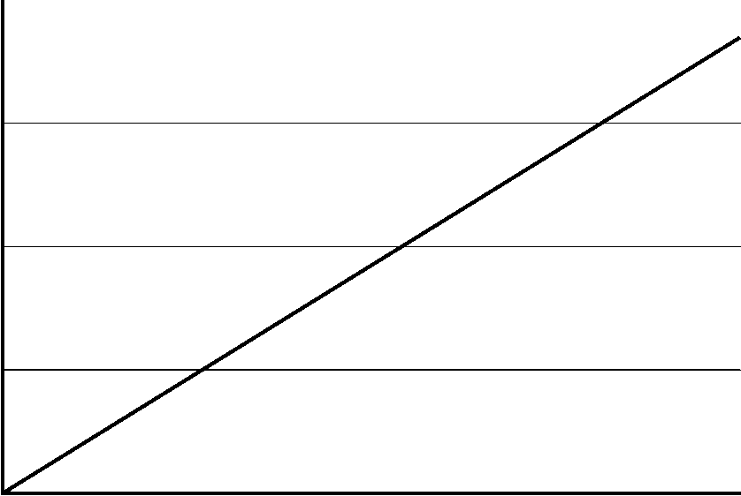
Fig. 1. figure caption.

TABLE I
TYPES SIZES FOR CAMERA-READY PAPERS
Item | Type Size  (points) | Appearance
Title | 14 | Bold
Author’s Name | 12 | Regular
Author’s Affiliations, and E-mail | 10 | Regular
Abstract | 9 | Bold
Sections Titles | 10 | Small capitals, centered in column, Roman Numerals
Subheadings | 10 | Italics, alphabetical numerals
Main Text | 10 | Regular
Subscripts and Superscripts in the Main Text | 8 | Regular
Figure Captions | 8 | Regular, centered in column, Arabic numerals
Table Captions | 8 | Small capitals, title case, centered in column, Roman numerals
References | 8 | Regular

Conference and Paper Submission Information
The “Call for Papers” of ICEMS2024 will be available on the conference website,
https://www.icems2024.com/.
This digest template file can be downloaded from the ICEMS2020 website. The deadline for the one-page digest submission is March 29, 2024. Please submit the digests (PDF) by uploading them through the conference website. Notification of acceptance will be given on June 28, 2024. Author(s) with accepted digests will be requested to submit the full papers (PDF) by no later than August 30, 2024 via the conference website together with the copyright forms which will also be available at the conference website. Do not forget your online registration as well as the final paper submission on the conference website.

References
- T. Sun, Z. Chen, and F. Blaabjerg, “Transient Stability of DFIG Wind Turbines at an External Short-circuit Fault,” Wind Energy, Vol.8, No.3, pp.345-360, 2005.
- S. M. Muyeen, J. Tamura, and T. Murata, Stability Augmentation of Grid-connected Wind Farm, Springer-Verlag London, October 2009.

